

**ACKNOWLEGMENT**

The presentation of this report gives us the feeling of the final front line toward achieving the BCA Degree, the activity of going through industrial orientation has bridged the gap between the academics and practical real-life work for us. It has prepared us to apply ourselves to become good IT professional. Naturally, it requires lot of people support to complete this project. We take this opportunity to acknowledge their support to us.

We sincerely thank our department for the academic improvement, it has provided to us during last year’s and finally provide us an opportunity for project work. We thank Miss. Heena Trivedi, from Smt. K.S.N. KANSAGARA MAHILA COLLEGE Computer Science department for her support throughout the project.

Last but not the least, we would like to thank our parents and our friends who had helped us indirectly throughout the project duration and have been the source of encouragement.

**PREFACE**

***“ THE EXPERINCE IS LIKE ADDING SUGAR TO SWEET”***

The age of information has gone; the correct area is the age of knowledge. These having knowledge would higher resources from the society & at the same time would be earning the higher returns. But knowledge as we know has changed drastically, to ensure that knowledge is imported to student, it is made mandatory by Saurashtra University for BCA student to work on a comprehensive project.

Here is the detailed report on the project I had made at Art gallery. It has developed on PHP, MYSQL and HTML & JAVASCRIPT.

We would like to express my gratitude to the member of my family for the support and encouragement I have receives from them.

**PROJECT PROFILE**

**Project title :** Art gallery

**Front End :** Javascript, HTML, PHP, CSS.

**Back End :** MySQL

**Target User :** Public

**Team Member & Roll No :** Gondha Reecha

Vadaliya Pooja

Bakori Bansi

**Documentation tool :** Microsoft Word 2007

**Operating System :** Windows 7, 8

**Web Server**  : Apache (XAMPP)

**Web Browser :** Google crome, Mozila Firefox

**Editor :** Macromedia Dreamweaver 8

**Guided By :** Miss. Heena Trivedi

**Submitted To :** Smt. K.S.N. Kansagara Mahila College .

**Project Duration :**  3 Months.

**PROJECT DESCRIPTION**

Our site contains much information and tips for the antique collector in indentifying and selecting quality antique arts.

We offer a lot of well researched information on Antique and Collectible items, like clay art, pencil art, paper art, rangoli art, sand art.etc…

This site is meant for people who likes purchasing antique arts and increase their collection in antique arts. Art Gallery have a place in the heart of each one of us.

We offer a lot of well researched information and antique collection. like clay art, pencil art, paper art, rangoli art, mahendi art, sand art etc…

Enjoy your stay and stack comfort in the fact that we stuff!! excitement for people just like you to enjoy and may be even learn off you think about antique art and yes, you will occasionally run across a funny or to

Antique provides that person like that connect the collector with the past let’s face it even the most contemporary furnishing of today will be the well sought after antiques of features generations.

***Software Requirement***

* ***Requirement:***
* *500 GB Hard Disk*
* *4 GB RAM*
* ***Software Requirements:***

*Front End Tool: PHP, HTML, JavaScript,CSS*

*Back End Tool: MySQL (XAMPP package)*

*Server: Apache (XAMPP package)*

Editer : Micromedia,Dreamviewer,Notepad

* ***Operating System:-***

*Windows XP*

*Windows 7 & 8*

* ***Browser***

*Mozilla firefox*

*Google chrome*

**E-R DIAGRAM**

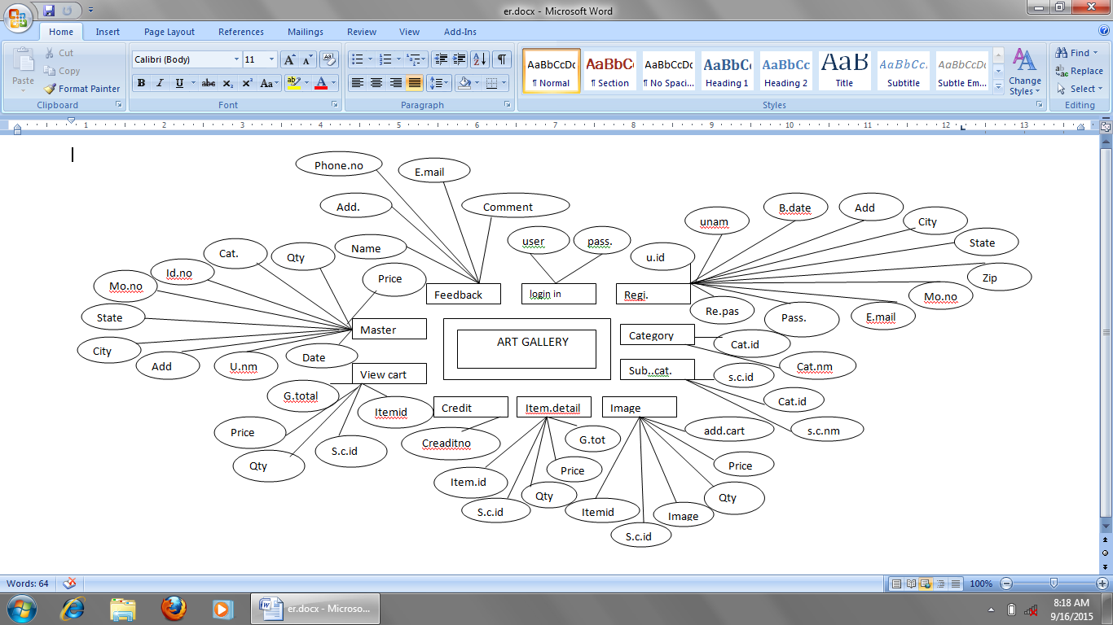

**DATA FLOW DIAGRAM**

Admin

User

CONTEXT LEVEL

USER SIDE

0-LEVEL

Login

User

1st level

User

Registration table

Login table

Image table

Credit table

Feedback form

ADMIN SIDE

0-LEVEL

Admin

Login

Validation &

verification

***1st level***

Admin

Login table

Add to card

Credit card

2nd level

Admin

Registration table

Image table

View cart

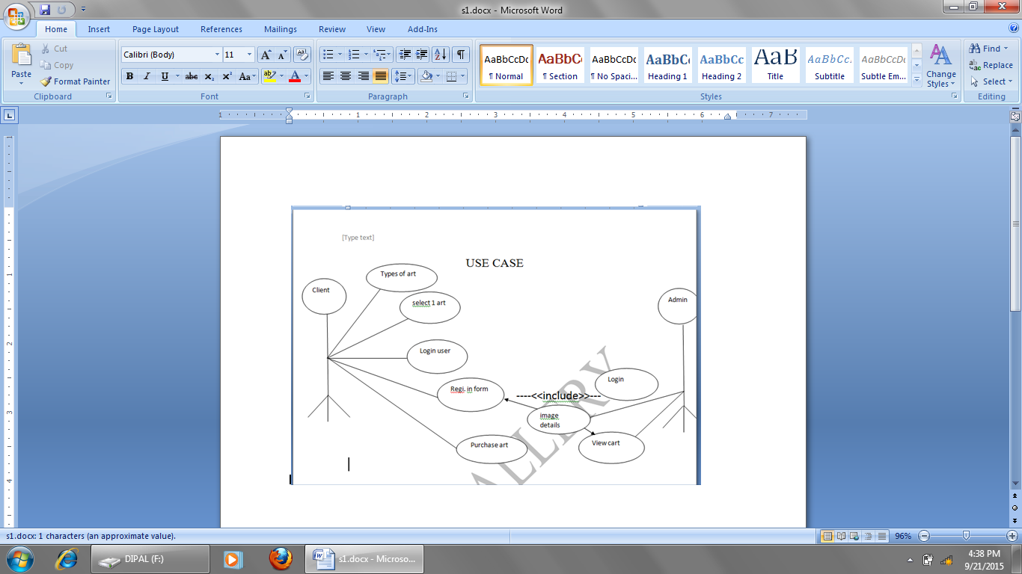

**Data Dictionary**

**Login**

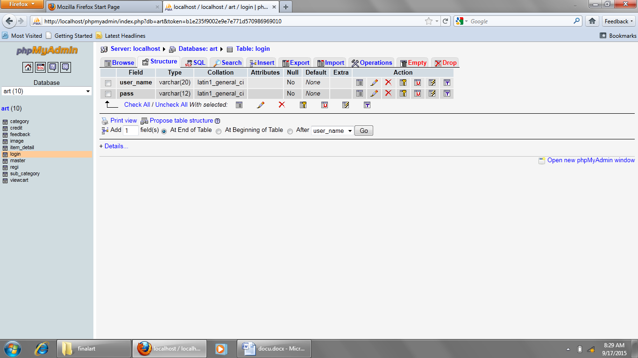

**Registration**

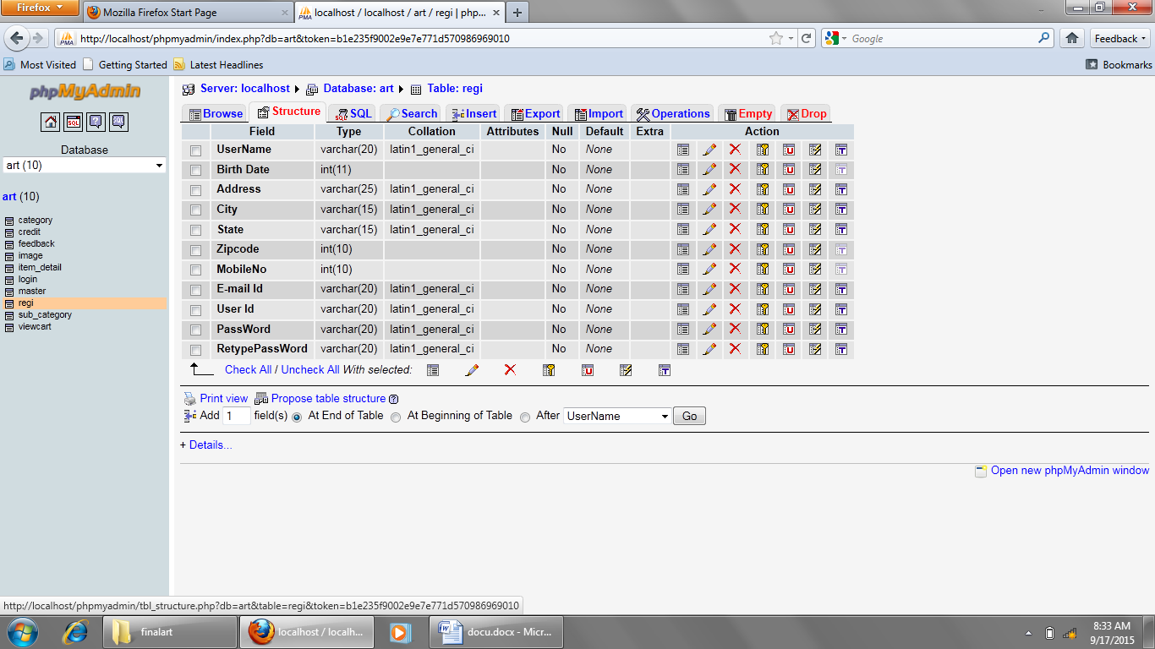

CATEGORY

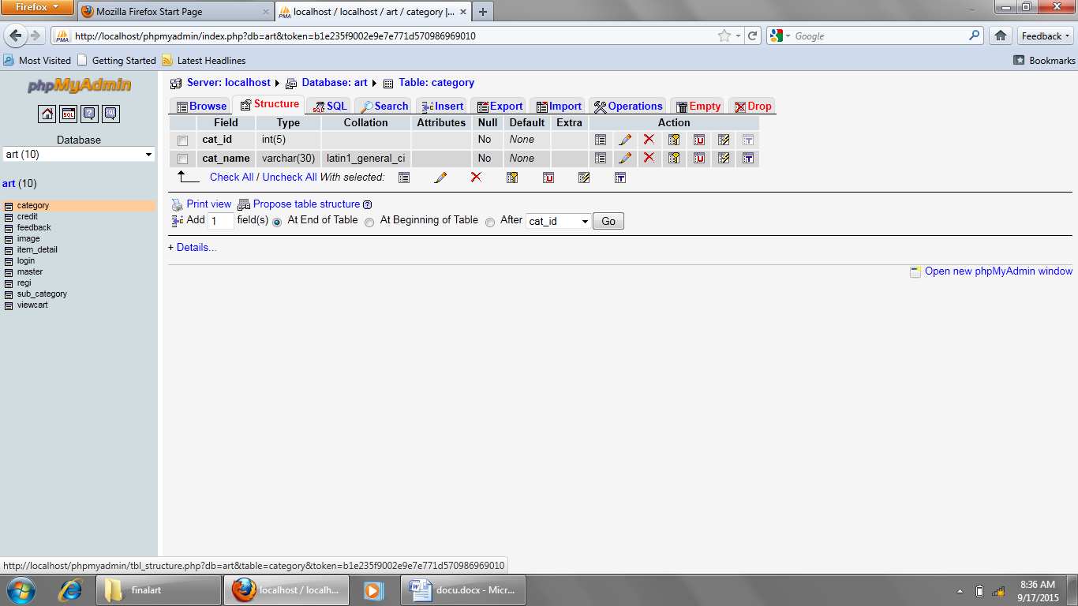

SUB CATEGORY

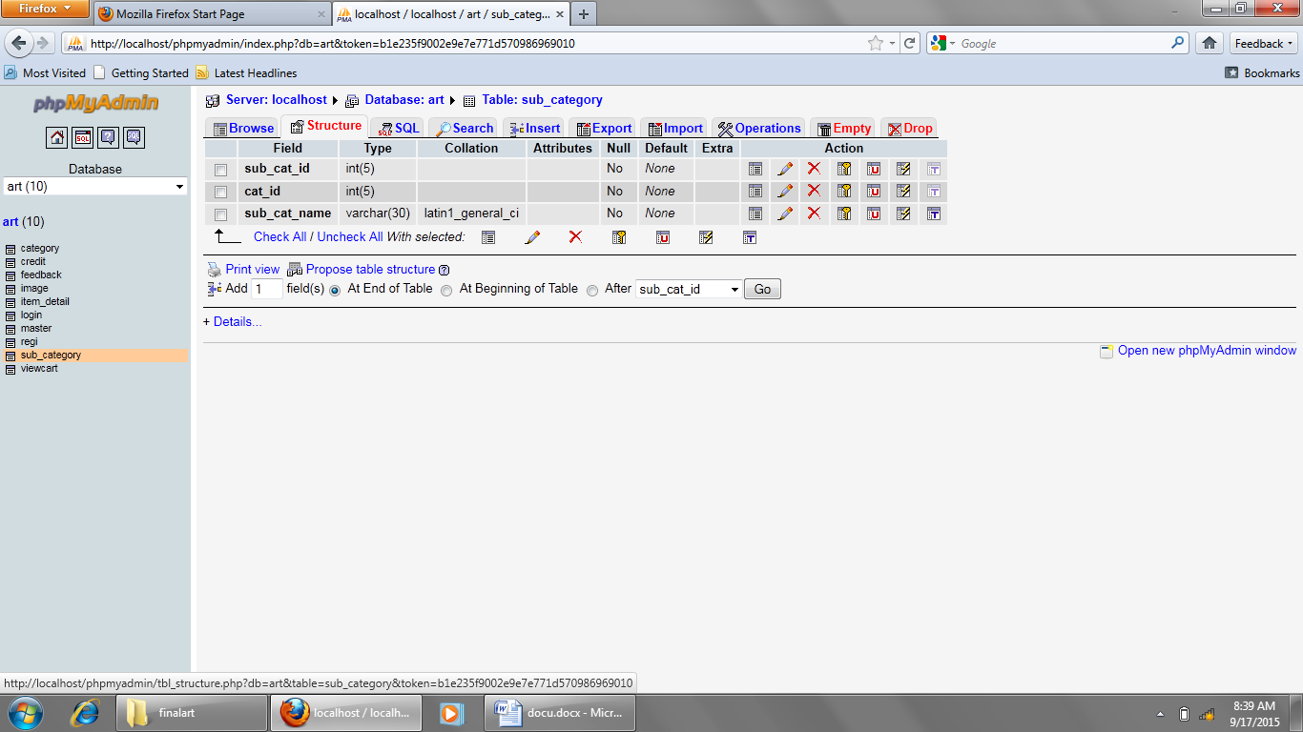

Image

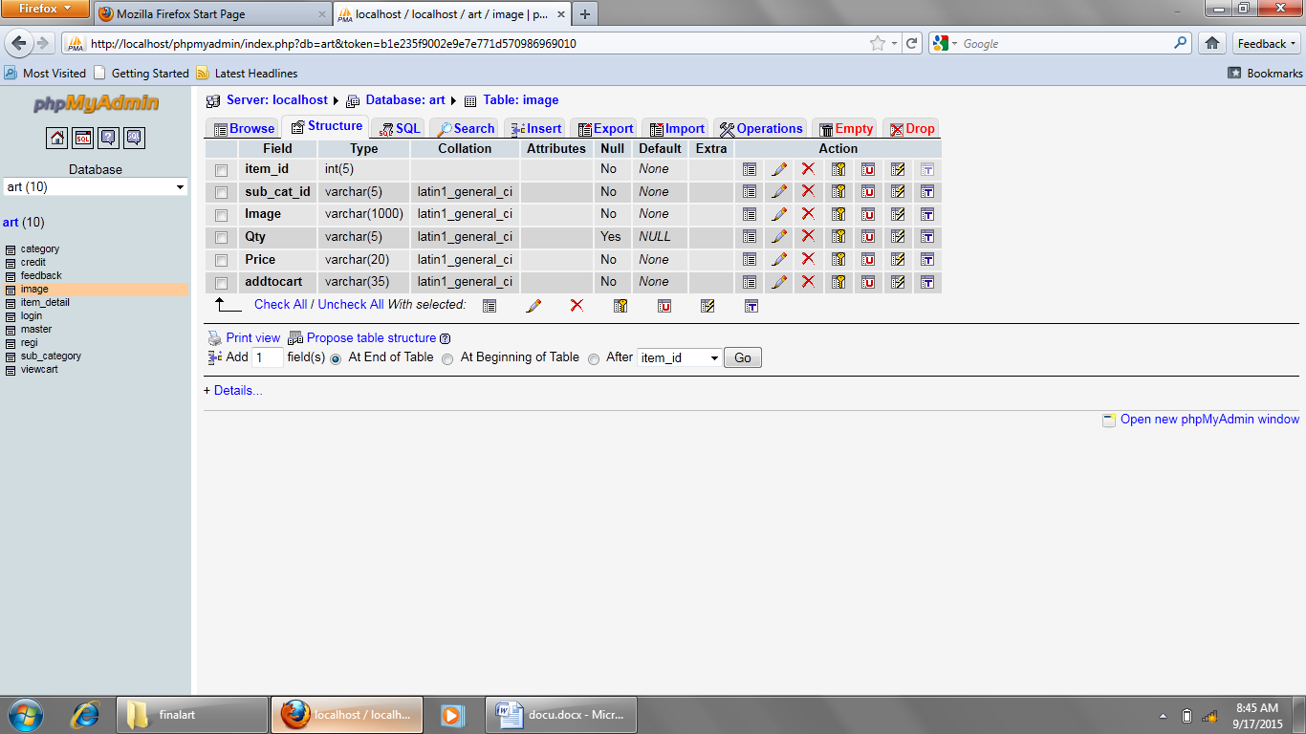

Item detail

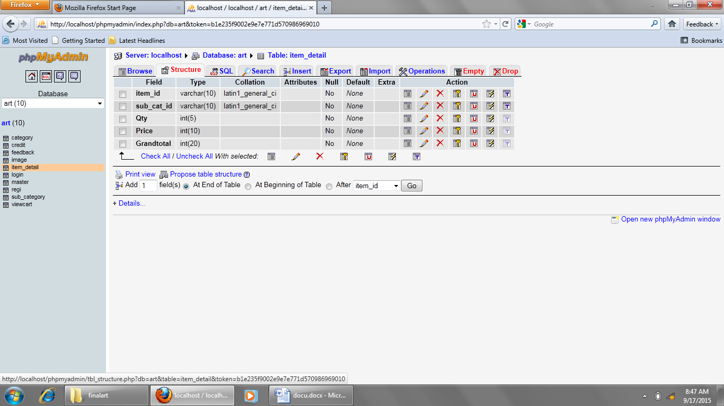

View cart

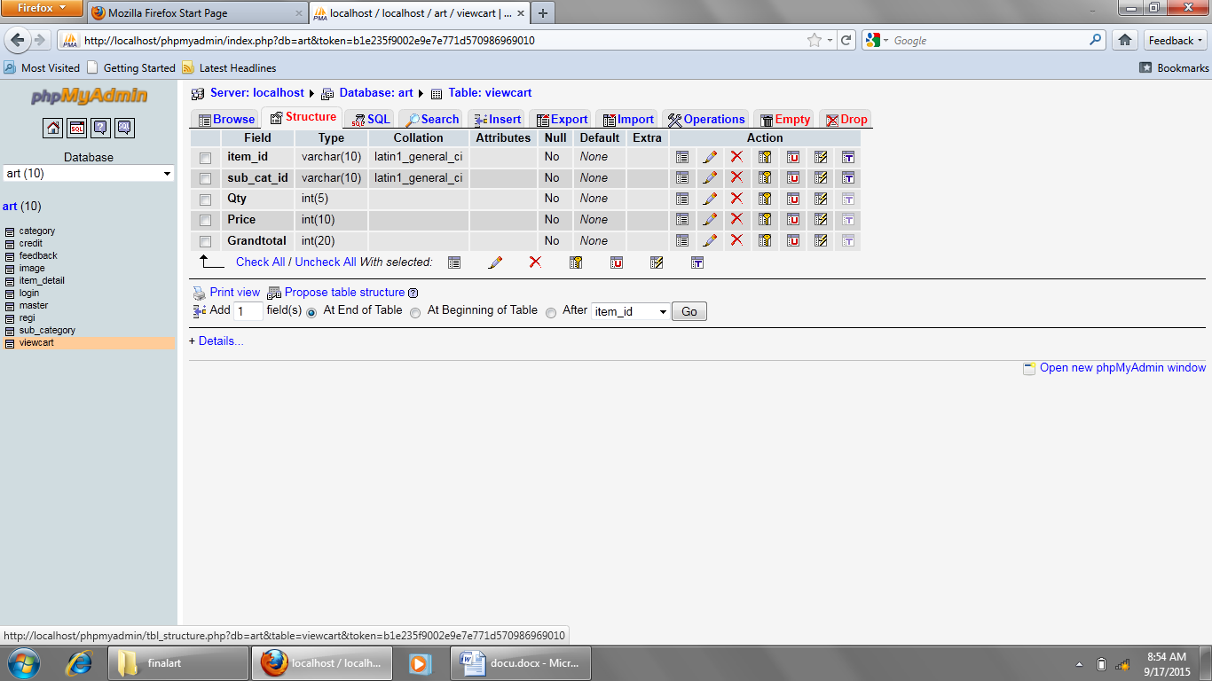

Master

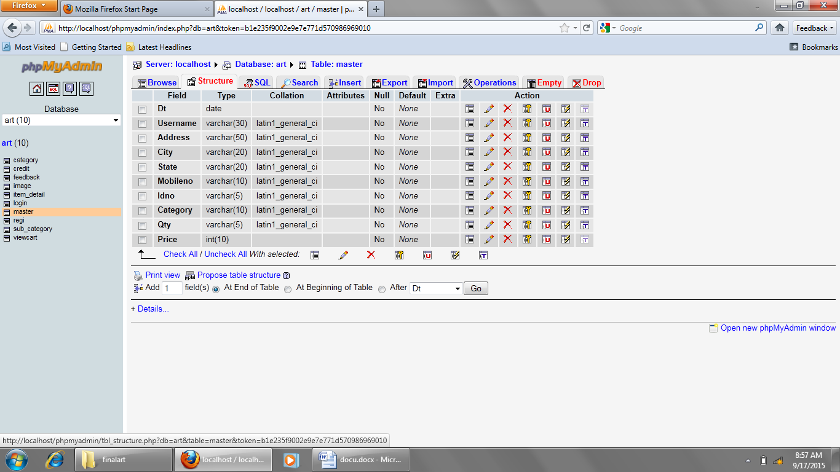

Feedback

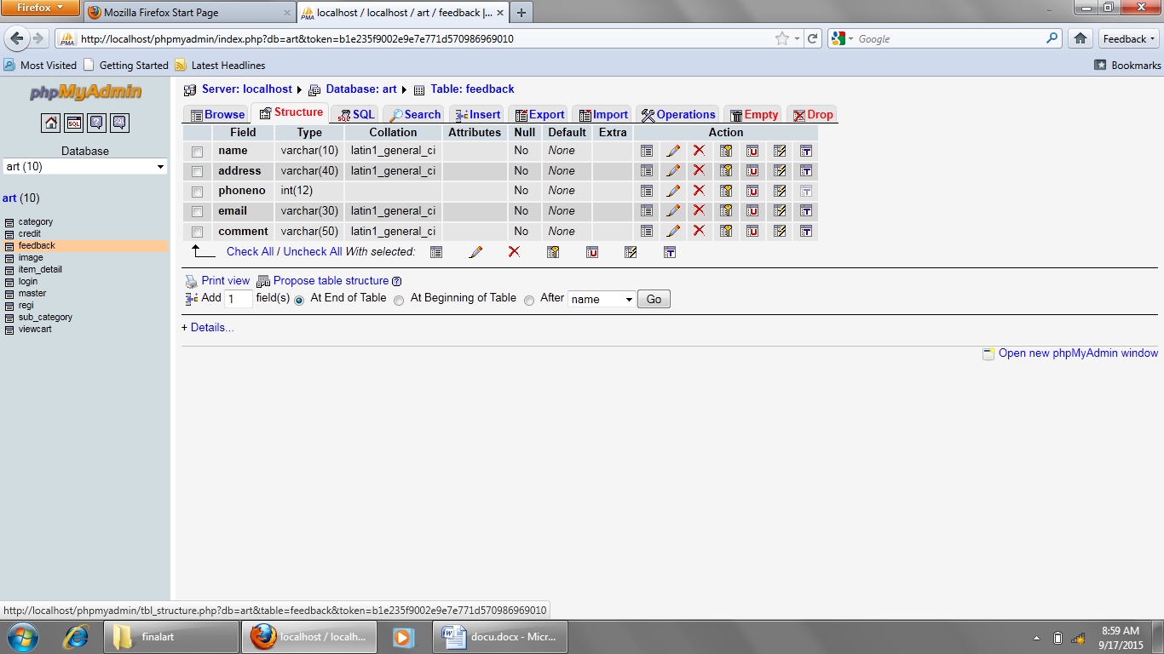

**Home page**

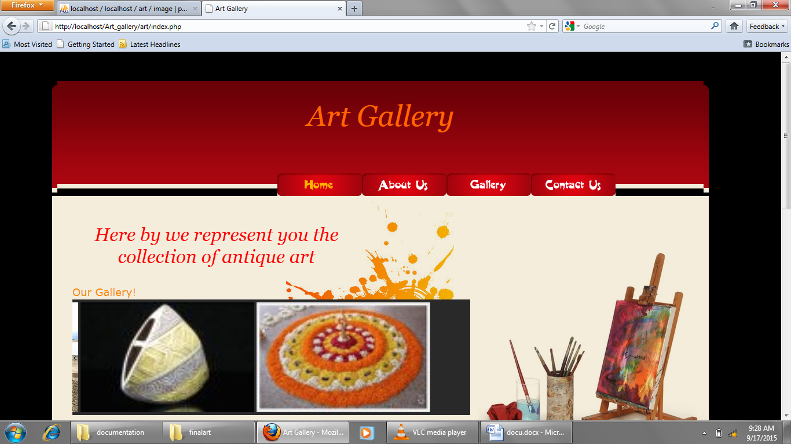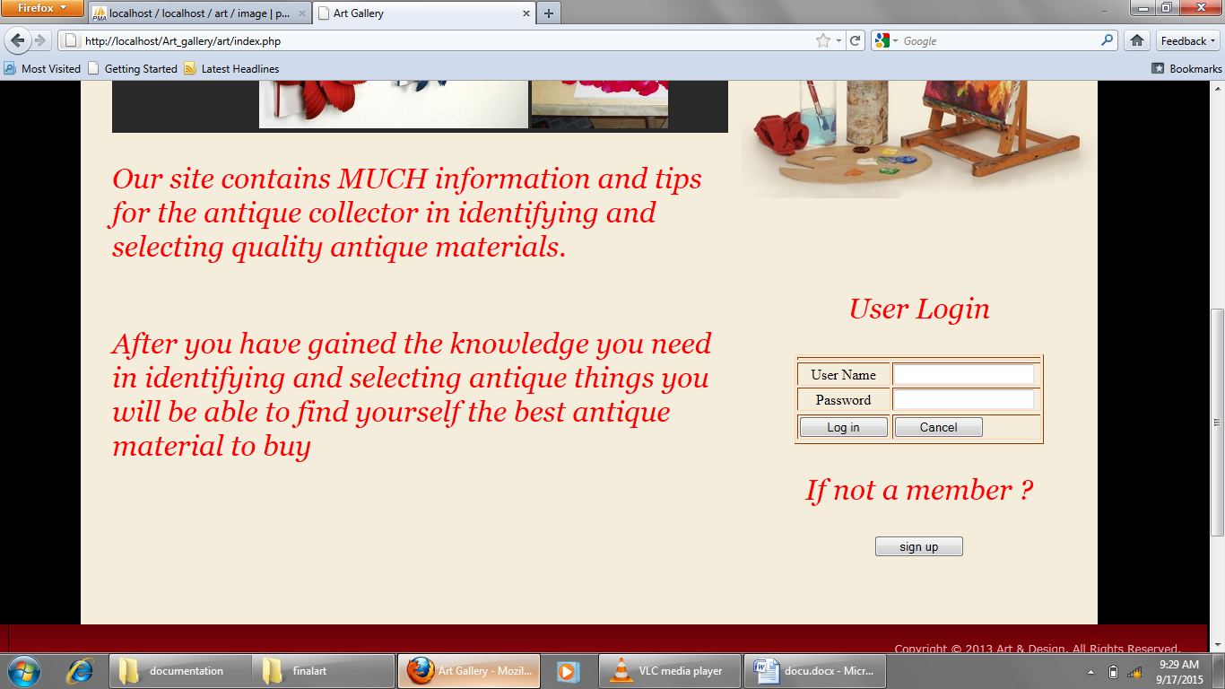

* In this form admin can login and check for the condition.

Gallery

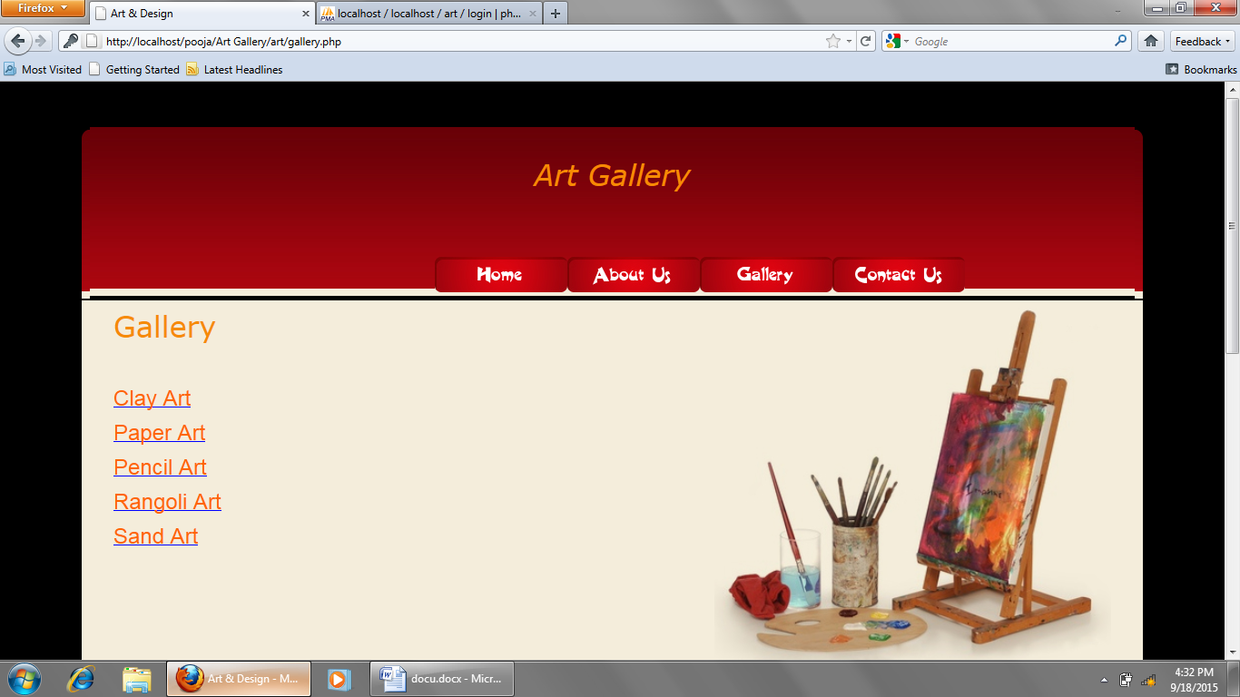

* this page is display all types of art

Add to cart

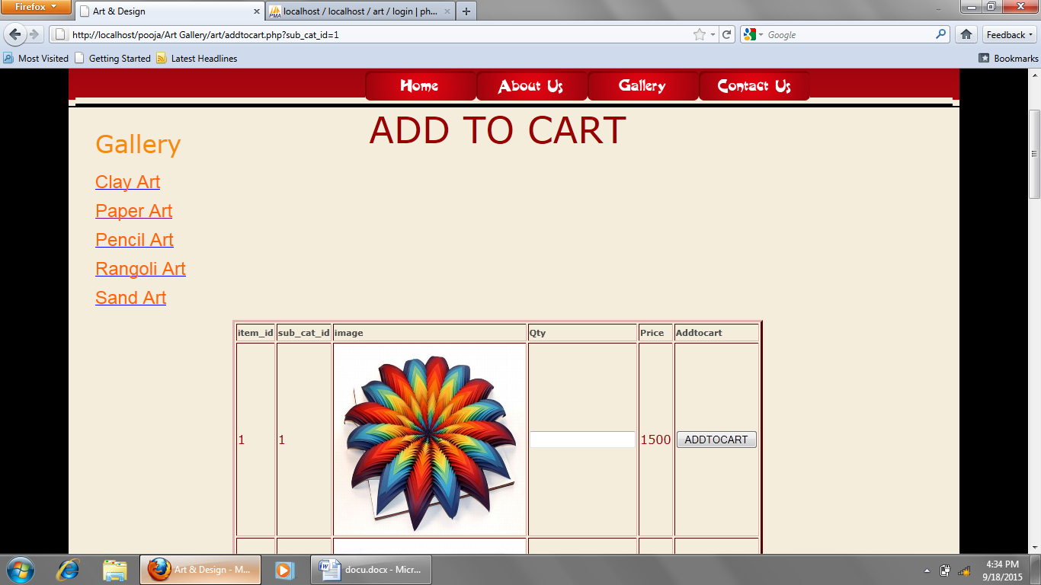

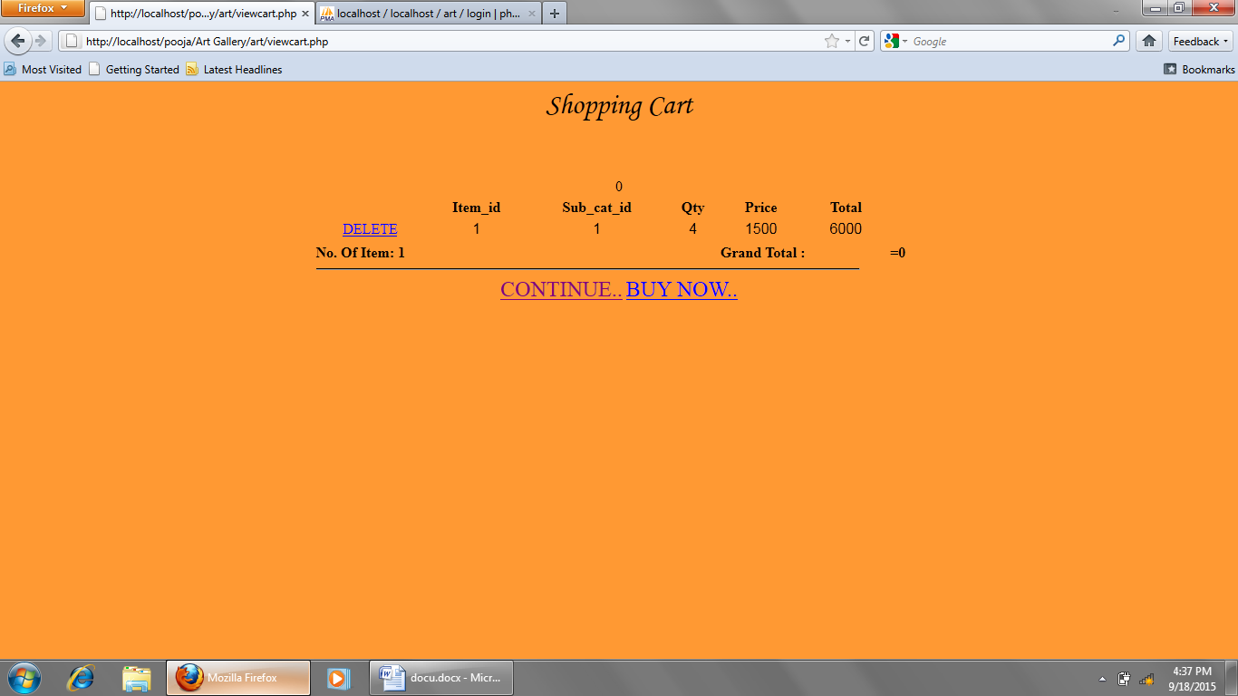

* Shopping cart: this page is for purchasing antique collection and add it to cart

Buy now

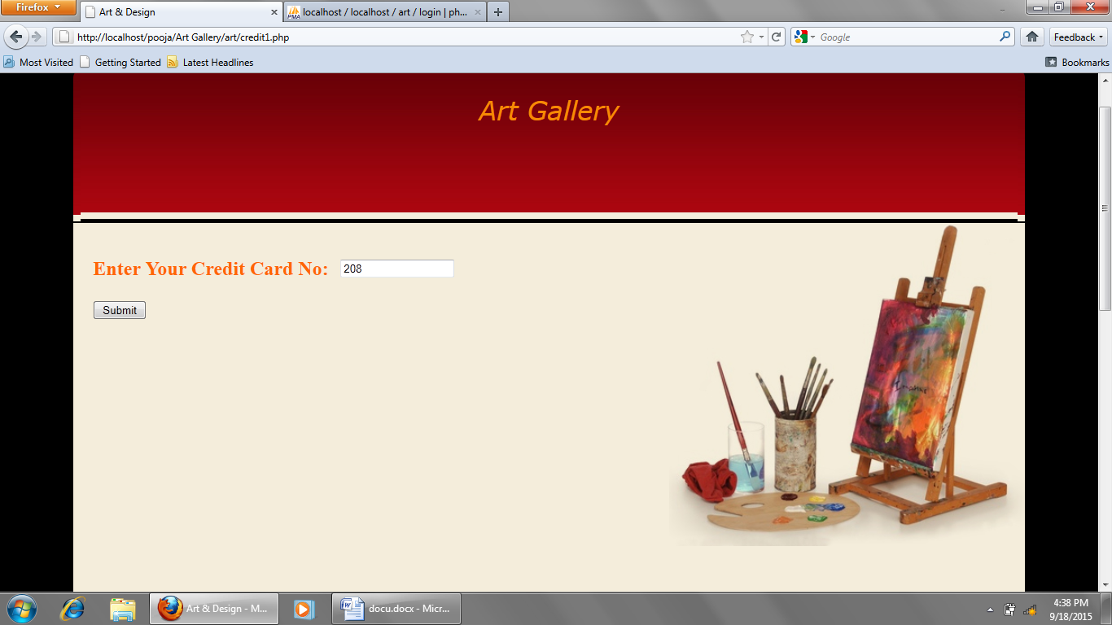

**GANTT CHART**

|  |  |  |  |  |  |  |  |  |  |  |
| --- | --- | --- | --- | --- | --- | --- | --- | --- | --- | --- |
| **Gantt Chart** | **JUN-15** | | **JULY-15** | | | **AUG-15** | | | **SEPT-15** | |
| **Requirement**  **Gathering** |  |  |  | | |  | | |  | |
| **Proposal Submit** |  |  |  | | |  | | |  | |
| **Analysis & Design** |  | |  |  | |  | | |  | |
| **Test Cases** |  | |  |  |  |  | | |  | |
| **Coding** |  | |  | |  |  |  | |  | |
| **Quality Assurance** |  | |  | | |  |  |  |  | |
| **Testing** |  | |  | | |  | |  |  |  |
| **Documentation** |  | |  | | |  | | |  |  |

**Gantt chart**

Test Case

|  |  |  |  |  |
| --- | --- | --- | --- | --- |
| Test case id | Test case name | Test case description | Test steps  step expected | Test case state |
| Login  01  User name | Validate login | To verify  Login that on login page user name must be valid | enter login an error msg  user name user name  which is entered  null & click  on login  button | Success |
|  |  |  | Enter wrong an error ms  Login user enter user  Name Name &  Validt unm | Success |
|  |  |  | Enter digit login scuess  Login user full nd  Name redirect page | Success |
| 02 password | Validate  Login | To verify  Login that on login page pass.must be validat | Enter login an error msg  Pass.which pass.must  Is null nd be entered  Click on  Login butt  On enter  Enter wrong an error ms  Login pass. enter pass.  Nd validate  Pass. | Success  Success |

|  |  |  |  |  |
| --- | --- | --- | --- | --- |
| registration 01  Id & user name | Validate registration | To verify submit that on register table  Id & name is valid | enter submit an error msg  id nd name id nd name  which is null must be en-  click on sub. tered  button | success |
|  |  |  | Enter wrong an error msg  Submit id & enter id & na  Name me validate  Id & name | success |
|  |  |  | Enter digit sub.success  Sub.id name full nd redire  Ct page | Success |
|  |  |  | enter wrong an error msg  sub.b date enter b  add. date add.vali-  date bdate  nd add. | success |
| 03  City & state | Validate registration | To verify sub.that on register table city nd state valid | Enter sub.  Nd state city nd state  Which is null must be  Click on sub. entered  Button | Success |
| |  |  |  |  |  | | --- | --- | --- | --- | --- | | + |  |  | enter wro en error  -ng subm message  -ite city& enter city  state and state  validate  city and  state | Success | |  |  |  | Enter digit submit  Submit successful  City and and  State redirect  Page | Success | | 04  Password  And  Retype password | Validate registration | To verify submite that on register password and retype pass | Enter an error  Submit message success  Password password  And and  Retype retype pas | | |  |  |  | Enter wro- an error  Ng submit message  E password entered  And password  Retype and  Password retype  Password  Validate  Password  And  Retype  password | Success | | **Limitation:**   * This project runs only Mozilla, Google chrome. * If you run this project, XAMPP must be installed in your computer. * This project are provided many security but not provided to a very high security. * At that time this project are provided a limited art but in future this project are provided many types of art.   **FUTURE ENHANCEMENT**   * **FEATURE OF SYSTEM :** * User friendliness * Security & Reliability * Flexibility * Easy to modify * **USER FRIENDLINESS:**   To make system more user friendly, following action have been taken:  System provides appropriate messages.Attempts are made to reduce response time  Attractive screen are generated so familiar person can also operate the system very comfortably.Maximum attempts are made to reduce data entry.   * **FLEXIBILITY:**   The system is made as possible as so that it can be used in any kind of situation and accommodate any kind of change in real world.For that at the time of designing all possibilities were considered and also possible changes in future were considered.   * **EASY TO MODIFY:**   As any system is never complete and the world is always changing it always required changing it so attempts are made to take system such that system can be modify easily for that system is divided into modules and they are furtherer divided into sub modules.  Instead of using ambiguous variable which are more readable and more nearer to it is name or meaning are used. | | | | |     WORK EXPERIENCE    Working experience with our project guide, with our facility member with our partner is one of the unique experiences of my life.  Our project guide Miss **Heena Trivedi** provided a full support to us. They always helped us just like a friends and companion and not just as professional guide they provide the information required by us any time. They personally worked hard for our project.  Also the other faculty members related to the computer department never denied to help us. For instant the topic such as JavaScript and PHP which were not in our syllabus but were used in our project were taught to us by them any problem by us in our dream project was immediately sorted out by them. Also the institute has provided us the immense help by leaps and bounds.  Last but not the least the overall experience of developing this project is as good as studying an entire new subject and fueling up our knowledge banks.  **Bibliography:**  **Books:-**   * PHP 5.0 * Analysis & design of information system * HTML and javascript     **Websites:-**   * [*www.google.com*](http://www.google.com) * [*www.mysql.com*](http://www.mysql.com)   ***Softwares:-***   * *Macromedia Dreamweaver* * *Adobe Photoshop CS4* | | | | |